Abductee: Yun Tae-kyong
Recorded Date: May 18th, 2005

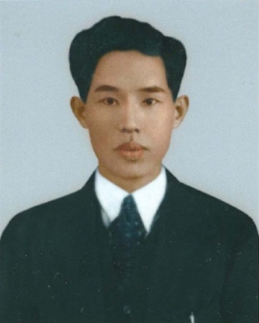
Profile of Abductee

Name: Yun Tae-kyong (male)
Date of Birth: November 27, 1909
Place of Birth: Seoul, South Korea
Last Address: 137-2 Gyonam-dong, Seodaemun-gu, Seoul, South Korea
Date of Abduction: September 1, 1950 (age 41)
Place of Abduction: Home
Occupation: Officer of Public Information Sector of the National Assembly’s Inspection Committee
Education/Career: Bae-jae Hakdang (Middle&High School)/ Staff of National Education Committee (educational affairs)
Dependents: Wife, 5 Children
Appearance/Personality: Tall, Slim, Curly hair/ Calm and Mild

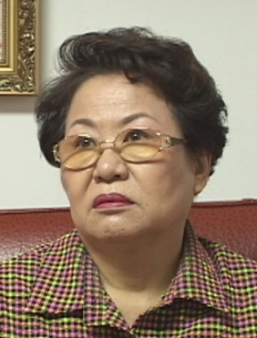
Profile of Testifier

Name: Yun Myeong-sik (born in 1939)
Relation: First daughter
Type of Witness: Direct witness
Summary of the Abduction

- When the Korean War broke out, the abductee was working as an officer of Public Information Sector of the National Assembly’s Inspection Committee.
- On the 31st of August 1950, his son’s birthday, he returned home for celebrating his son’s birthday.
- Next day at dawn, as he’d just woke up, in underwear he was tied up and arrested by Internal Bureau officers.
- Well-known people lived in and around abductee’s town, were abducted almost the same day.
- It was heard later that Kim Chong-ki had been taken to Seodaemun(West Gate) Prison.
- Paid visit was rejected and the effort to find his corpse was failed.

Description of abduction

Q. Didn’t your family evacuate Seoul when the war broke out?
Just before the Korean War broke out, my father, until then was working on educational affairs at the National Education Committee, just changed his career and started to work for the Public Information Sector of the National Assembly’s Inspection Committee. As he was a member of the Inspection Committee, many people tried to bribe him, but my father always made us return any illicit goods back to the very person who had sent them.
When the war broke out, my father fled to southern region, only to return home, unable to cross the bridges destroyed by South Korea. From then on, he moved from one place to another, fearful of his safety since public servants were the main target of abduction by the North. He was so worried about the family that he tried to send three older children to a place other than Seoul while my mother and two toddlers stayed at home.

Q. Can you describe the situation when your father was abducted, in detail?
My parents had no relatives living in countryside, so their three children including me were sent to Munsan, where a distant relative of my mother’s was residing. On August 31st 1950, my uncle came to pick us up on a bicycle for a family dinner in Seoul to celebrate my younger brother’s birthday. My father also came and the whole family enjoyed precious time together. We were supposed to go back to our hiding places after dinner, but as we had not seen each other for a long time, we decided to spend the night together.
Next day at dawn, two strangers came to our house and told us that my father should go with them. He was still in his undershirt, and asked the strangers to at least give him time to dress. However, they hauled my father by the arms and told us that he would soon return home. I still vividly remember the scene.
My father was a polite and tidy man who cared very much about manners, so it was a shock for me to see him leaving the house in his undershirt. At first I believed the words of the strangers and thought he would return soon. However, on seeing my mother worrying, I could feel that something was wrong.
Reason behind the Abduction

Q. Why do you think he was abducted?
On the same day my father was abducted, a female obstetrician who was living our neighborhood was also abducted. According to rumors, the son of pharmacist in my town converted to socialism and became an officer in the Internal Affairs Agency.
People in my town presumed that he provided information of the abductees to the agency to premeditate the abduction. That’s a reasonable guess because well-known people lived in and around my town, were abducted almost the same day.

News after the Abduction

Q. Did you make any effort to find him back?
When my mother found out that my father was locked up in the (North Korean) Security Bureau, she told me to deliver his clothes to the bureau. From the next day after my father was arrested, I went to the Bureau every day, which was stationed in a red brick building of the National Library (now the Lotte Department Store in Myeong-dong, Seoul).
Next to the library was the headquarters of the Korea Development Bank. There was another girl waiting for her father just like me. We sat on the stairs of a building across the road, anxious to see our fathers. One day, I saw my father being tied up and dragged to another building with other prisoners. I could notice my father the moment I saw him because he was a tall man with curly hair. But I could not give him the clothes my mother had told me to deliver.
After that, we were informed from someone we don’t know well that he was detained in cell no.88 at the Seodaemun Prison. We tried to pay him a visit, but all our requests were rejected. When Seoul was recaptured on September 28, the North Korean Army shot the inmates in the Seodaemun Prison to death, and survivors were abducted to the North. On hearing this news, my mother ran to the prison with my baby brother on her back. She lifted every corpse to find the body of my father, but nothing was found.
I remember the Association of Families of Persons Kidnapped at the time of the war. After the truce when everyone was suffering from poverty, many women like my mother, whose husbands and sons were abducted all the sudden, fought for their return. I myself participated in the association’s rally to call for repatriation of the abductees. It was when I was a first grader in Kyung-gi girls' middle school. After school, I went on a street rally to inform people more about the need to address the Abductees’ issue.
I remember getting on a car and speaking in front of the public through a microphone for the safe return of my father. At that time, the public acknowledged the fact that many people were forcefully dragged to the North, but everyone was too busy to take care of their own family. Although we devoted ourselves in bringing our family members back, we could not gather much attention from the public and were unable to get any help.

